A FIELD PROJECT REPORT ON

**“STUDENT REGISTRATION FORM USING FRONT-END APPLICATIONS”**

Submitted in partial fulfilment of the requirements for the award of the degree

**BACHELOR OF TECHNOLOGY**

in

**COMPUTER SCIENCE AND ENGINEERING**

Submitted by

BATCH-11

|  |  |
| --- | --- |
| N.Sai Akhil | (231FA04068) |
| G.Naga Surya | (231FA04268) |
| K.Likhitha | (231FA04411) |
| K.Harshitha Reddy | (231FA04788) |



Department of Computer Science Engineering

School of Computing and Informatics

Vignan’s Foundation for Science, Technology and Research (Deemed to be University) Vadlamudi, Guntur, Andhra Pradesh-522213, India

**APRIL, 2025**

**CERTIFICATE**

This is to certify that the field project entitled “STUDENT REGISTRATION FORM USING FRONT-END APPLICATIONS” being submitted by N.Sai Akhil (231FA04068),G.Naga Surya(231FA04268),K.Likhitha-(231FA04411) and K.Harshitha(231FA18157) in partial fulfilment of Bachelor of Technology in the Department of Computer Science Engineering, Vignan’s Foundation For Science Technology & Research (Deemed to be University), Vadlamudi, Guntur District, Andhra Pradesh, India, is a bonafide work carried out by them under my guidance and supervision.

|  |  |
| --- | --- |
| **Head of the Department** | **Guide** |

**DECLARATION**

We hereby declare that our project work described in the field project titled “STUDENT REGISTRATION FORM USING FRONT-END APPLICATIONS” which is being submitted by us for the partial fulfilment in the department of Computer Science Engineering, Vignan’s Foundation for Science, Technology and Research (Deemed to be University), Vadlamudi, Guntur, Andhra Pradesh, and the result of investigations are carried out by us under the guidance of DR.O.Bhaskar.

N.Sai Akhil (231FA04068) _____________

G.Naga Surya (231FA04268) _____________

K.Likhitha (231FA04411) _____________

K.Harshitha (231FA04788) _____________

**TABLE OF CONTENTS**

|  |  |  |  |
| --- | --- | --- | --- |
| CHAPTER NO | | CONTENTS | PAGE NO |
| 1 |  | Introduction | 1 |
|  | 1.1 | Problem Definition | 2 - 4 |
|  | 1.2 | Existing System | 4 - 5 |
|  | 1.3 | Proposed System | 5 - 7 |
|  | 1.4 | Literature Survey | 7 - 10 |
| 2 |  | System Requirements | 11 |
|  | 2.1 | Hardware & Software Requirements | 12 - 14 |
|  | 2.2 | Software Requirements Specifications(SRS) | 15 - 16 |
| 3 |  | System Design | 17 |
|  | 3.1 | Modules Of System | 18 - 19 |
|  | 3.2 | UML Diagram | 19 |
| 4 |  | Implementation | 20 |
|  | 4.1 | Simple code | 21 - 25 |
|  | 4.2 | Test Cases | 25 |
| 5 |  | Results | 26 |
|  | 5.1 | Output Screens | 27 - 29 |
| 6 |  | Conclusions | 30 - 31 |
|  |  | References | 32 |

CHAPTER 1

INTRODUCTION

**1. INTRODUCTION**

**1.1 Problem Definition**

In today’s digital world, educational institutions increasingly rely on web-based platforms to manage operations efficiently. One of the most critical areas that benefit from digital solutions is student registration. Traditionally, student registration was handled manually or through physical forms, which required significant administrative effort and increased the likelihood of human error. With the growing demand for more streamlined, efficient, and error-free processes, web-based student registration forms have become an essential tool for educational institutions.

The current student login and registration system has multiple functional, security, and user experience deficiencies that need to be addressed. The login form does not verify user credentials against a database, making it prone to unauthorized access. Registration data is not stored persistently, preventing proper authentication and tracking of users. The OTP verification mechanism is simulated through an alert but lacks actual validation. There is no mechanism to prevent duplicate registrations using the same email or phone number, and the system does not provide feedback for incorrect login attempts, leading to user frustration.

Security concerns also need to be addressed, as passwords are stored without encryption, making them vulnerable to breaches. The absence of brute-force attack prevention mechanisms allows repeated login attempts. No CAPTCHA or other bot-prevention measures are implemented to protect against automated attacks. OTP authentication lacks real-time validation, making the verification process unreliable. The system does not enforce SSL encryption, leaving user data exposed to potential cyber threats.

The interface does not allow users to navigate back to the login page from the registration form easily. Input fields do not provide real-time validation, leading to potential errors in data submission. There is no "Forgot Password" option for account recovery, causing inconvenience to users who lose access. The system lacks a mobile-friendly design, making it difficult to use on different screen sizes. Users do not receive clear confirmation messages upon successful registration or login failure.

To improve the login and registration process, a backend database such as MySQL, Firebase, or MongoDB should be implemented to securely store and validate user credentials. Proper authentication should be developed using session-based or token-based security mechanisms. Real OTP generation and validation using an API service such as Twilio or Firebase Authentication should be enabled. Duplicate accounts should be prevented by checking if the email or phone number is already registered. Users should receive real-time feedback messages to help them correct errors before submission.

Strengthening security features is crucial. Passwords should be encrypted using strong hashing algorithms like bcrypt or Argon2 before storing them. SSL encryption should be implemented to secure data transmission and protect against cyber threats. CAPTCHA or other bot-prevention techniques should be introduced to safeguard against automated attacks. The number of failed login attempts should be limited to prevent brute-force attacks. Multi-factor authentication should be implemented for additional security measures.

Enhancing user experience should be a priority. The interface should be user-friendly and responsive across all devices, including desktops, tablets, and smartphones. Real-time validation should be implemented to guide users in providing the correct information. An intuitive "Forgot Password" feature should allow users to reset their passwords securely. A password visibility toggle should be introduced to improve usability without compromising security. Confirmation messages should be displayed upon successful registration, login, or errors encountered.

Accessibility improvements should also be considered. Compliance with WCAG (Web Content Accessibility Guidelines) should be ensured to make the form accessible to people with disabilities. Screen-reader compatibility should be added to enhance usability for visually impaired users. High-contrast color schemes and readable font sizes should be used to improve accessibility for all users.

Future enhancements should include integrating backend systems to store and manage student data efficiently. Email verification should be implemented to prevent fake registrations and ensure account authenticity. Automatic role-based access should be enabled, where students, teachers, and administrators have different permissions. Analytics tools should be developed to track user activity and improve platform efficiency. AI-powered chatbots should be introduced to assist users in navigating the registration process.

The existing student login and registration system lacks essential security, functional, and user experience features necessary for a seamless process. Implementing the recommended enhancements will significantly improve security, usability, and efficiency. By integrating backend authentication, real-time validation, strong encryption, and accessibility features, the system can offer a robust, secure, and user-friendly experience for students and administrators alike. With these improvements, educational institutions can ensure a seamless digital registration process, making it easier for students to access their learning resources while reducing administrative burdens.

In today's digital world, educational institutions increasingly rely on web-based platforms to manage their operations efficiently, and **student registration** is one of the most critical areas that benefit from such digital solutions. Traditionally, student registration processes were handled manually or through physical forms, requiring significant administrative effort and increasing the likelihood of human error. With the increasing need for more streamlined, efficient, and error-free operations, **web-based student registration forms** have become an essential tool for educational institutions.

The **Student Registration Form** designed in this project is a web application intended to collect vital information from students during their registration process. This form collects essential personal data such as first name, last name, email address, phone number, date of birth, gender, and address. The aim is to create an easy-to-use interface where students can quickly and accurately provide their details, enabling institutions to gather and manage student data more efficiently.

The design of the form incorporates **HTML** for the structure and **CSS** for styling, ensuring both functionality and visual appeal. By focusing on **user-centered design**, this registration form is built with accessibility and ease of use in mind, making sure that users, regardless of their technical ability, can fill out and submit the form effortlessly. The design also prioritizes responsiveness, meaning the form is mobile-friendly and adjusts smoothly to different screen sizes, such as desktop, tablet, and smartphone devices.

A key aspect of the form's functionality is its **input validation**. Form fields are equipped with basic validation to ensure that users provide the required information in the correct format. This reduces errors and ensures that institutions collect accurate, complete, and usable data. For example, the email field will only accept properly formatted email addresses, and the phone number field requires a valid phone format, ensuring that all entered data is valid before submission.

Ultimately, this **Student Registration Form** serves as an effective solution for institutions looking to modernize their registration processes, offering a user-friendly, secure, and reliable tool that simplifies the process for both students and administrators.

**1.2 Existing System**

The existing system is a basic student login and registration form built using HTML, CSS, and JavaScript, providing a simple and interactive user interface. However, it operates entirely on the client side without a backend or database, making it suitable for front-end demonstrations but inadequate for real-world applications that require secure authentication, data storage, and validation.

Currently, the login form consists of an email and password field, but it does not authenticate users against any stored credentials. When a user submits the login form, the system merely hides the login container and displays the registration form, instead of verifying the entered credentials. This means any user can proceed without valid authentication, making the system ineffective for real-world applications.

The registration form collects essential details such as full name, email, phone number, and password. Additionally, it includes an OTP verification field, which is meant to enhance security by confirming the phone number. However, the OTP system is simulated through a JavaScript alert message rather than an actual verification mechanism. Since there is no server-side validation or integration with an OTP service provider, users can bypass this step by simply entering any value in the OTP field. This defeats the purpose of OTP verification, which is essential for confirming user identity.

Another major limitation of this system is the absence of persistent data storage. Currently, user information is not stored anywhere, meaning that after a page refresh, all entered data is lost. In a real-world scenario, a database such as MySQL, Firebase, or MongoDB would be required to store and retrieve user credentials securely. Without a backend, users cannot log in after closing the page, making the system non-functional beyond a single session.

Security is also a significant concern in the existing system. Passwords are collected through an input field but are not encrypted or stored. In a real-world application, passwords should be hashed using strong encryption algorithms like bcrypt before storing them in a database. Additionally, there are no mechanisms to prevent brute-force attacks, meaning an attacker could repeatedly attempt to log in using different password combinations. Moreover, the system lacks HTTPS enforcement, which means that in a real-world deployment, user credentials could be intercepted during transmission, leading to data breaches.

From a usability perspective, the system lacks important features such as an error-handling mechanism for incorrect logins, real-time form validation, and navigation controls. For example, after filling out the registration form, users are not redirected back to the login page, leaving them uncertain about the next steps. Similarly, there is no indication if an incorrect password is entered during login, which can frustrate users.

Another limitation is the lack of a "Forgot Password" feature. In a real-world scenario, users often forget their passwords and need a way to reset them securely. A backend system would typically generate a password reset link and send it to the user’s registered email, allowing them to create a new password. Without this feature, users who forget their passwords would have no way to regain access to their accounts.

Accessibility is another area that needs improvement. While the current design is visually appealing, it does not fully comply with Web Content Accessibility Guidelines (WCAG). For example, users with visual impairments may struggle with the form due to the lack of screen-reader compatibility. Additionally, there are no high-contrast options for better visibility, and the form does not provide audio or text-to-speech support for users with disabilities.

The system also lacks role-based access control. In a real-world application, different types of users, such as students, teachers, and administrators, should have different levels of access. For example, students should only be able to access their personal information, while administrators should be able to manage multiple student accounts. Without such functionality, the system remains limited in scope and usability.

Furthermore, since the current system does not connect to an external database, there is no way to track user activity or generate reports. In a real-world implementation, an analytics feature could help educational institutions track the number of registrations, login attempts, and failed logins to identify potential security threats or system issues.

To improve the system, several enhancements should be implemented. First, a backend server using technologies such as Node.js, Python (Django/Flask), or PHP should be integrated to handle authentication, data storage, and OTP verification. A database should be used to store user credentials securely, ensuring persistence beyond a single session. Additionally, real OTP verification using an SMS gateway like Twilio or Firebase Authentication should be implemented to ensure authenticity. Security features such as password hashing, HTTPS enforcement, and brute-force protection should be added to safeguard user data.

User experience can also be improved by implementing better navigation controls, error handling, and real-time validation. Users should be able to navigate between login and registration forms easily, and error messages should be displayed when incorrect credentials are entered. A password reset feature should also be added to allow users to recover their accounts.

Accessibility improvements should include adding screen-reader support, high-contrast mode, and alternative text for non-text elements. Implementing multi-language support would also enhance usability for users who are not proficient in English.

**1.3 Proposed System**

The proposed system aims to revolutionize the student registration and login process by incorporating a comprehensive, secure, and efficient approach. With the increasing demand for digital transformation in educational institutions, the need for a reliable and robust system is more crucial than ever. The system will not only address the limitations of the current implementation but also introduce innovative features to enhance security, accessibility, and usability.

One of the major improvements in the proposed system is the implementation of a structured and secure backend. Unlike the current system, which operates solely on the client side and lacks data persistence, the proposed system will integrate a backend server using technologies like Node.js with Express, Python with Django/Flask, or PHP with Laravel. This backend will be responsible for processing login and registration requests, verifying credentials, and storing user data securely. The database, whether MySQL, PostgreSQL, or MongoDB, will ensure proper data management, allowing institutions to access student records efficiently.

To ensure high security, the system will use encryption techniques for storing sensitive information. Passwords will be hashed using industry-standard encryption algorithms like bcrypt or Argon2, preventing them from being stored in plain text. Additionally, multi-factor authentication (MFA) can be implemented to add an extra layer of security by requiring students to verify their identity via email or SMS. The use of HTTPS will further secure data transmission, preventing unauthorized interception of student credentials.

Another enhancement is the integration of a fully functional OTP verification system. In the existing implementation, OTP verification is simulated through JavaScript alerts, which does not provide actual security. The proposed system will integrate real-time OTP services using platforms like Twilio, Firebase Authentication, or an SMS gateway API. Upon registration, an OTP will be sent to the user's phone or email, and successful verification will be mandatory to complete the process. This step ensures authenticity and prevents spam or fake registrations.

The login system will be improved with better validation and authentication measures. In the current system, users can switch between login and registration screens without any actual credential verification. The new system will validate login credentials against the database, ensuring only registered users with valid passwords can access their accounts. Account lockout mechanisms will be introduced, temporarily disabling accounts after multiple failed login attempts to prevent brute force attacks. CAPTCHA verification may also be added to deter automated bot attacks.

Another major improvement is session management and user tracking. The existing system does not maintain sessions, meaning that users are logged out once they refresh the page. The proposed system will use session cookies or JSON Web Tokens (JWT) to maintain active sessions, allowing students to stay logged in securely. Session expiration and automatic logout features will be implemented for additional security, ensuring that inactive sessions do not pose a security risk.

The user interface will be significantly improved for a more seamless experience. While the current system provides basic form fields, the proposed system will introduce real-time validation with meaningful error messages. Fields like email, password, and phone number will be validated dynamically, preventing incorrect submissions. The password field will have strength indicators, helping users create secure passwords. Additionally, a "Show Password" toggle will be added to reduce input errors.

A dedicated student dashboard will be introduced, allowing users to manage their accounts efficiently. Once logged in, students will have access to their profile page, where they can update their personal details, change passwords, and view their registration history. The dashboard will also include a notification panel to alert students about important updates, such as pending verifications or incomplete registrations.

Accessibility will be a key focus of the new system, ensuring compliance with Web Content Accessibility Guidelines (WCAG). The interface will be designed to be screen-reader-friendly and optimized for users with disabilities. Features like keyboard navigation, high-contrast mode, and voice assistance compatibility will be introduced to make the platform inclusive for all students.

Another important improvement is the implementation of an administrator panel. Unlike the current system, where registration data is not stored, the proposed system will provide a management portal for school or college administrators. Administrators will be able to verify student registrations, approve or reject requests, and reset passwords if needed. Role-based access control (RBAC) will ensure that only authorized personnel have access to critical administrative functions, preventing unauthorized data modifications.

To ensure reliability and scalability, the system will be deployed on cloud-based infrastructure or a secure hosting service. Cloud-based deployment ensures that student data is accessible anytime and backed up regularly. Auto-scaling features will be implemented to handle high traffic, ensuring the system remains functional even during peak registration periods.

Furthermore, the proposed system will support integration with Learning Management Systems (LMS) like Moodle, Blackboard, or Google Classroom. Once students register successfully, their accounts can be automatically linked to the institution’s LMS, providing a seamless experience for online learning. APIs can be developed to allow external systems to interact with the student database, making the system more versatile.

A feedback system will also be integrated, allowing students to report issues or suggest improvements. This feature will enable institutions to gather insights and make continuous enhancements to the platform. The system will also provide analytics dashboards for administrators, displaying key metrics such as total registrations, active students, and login trends. These analytics will help institutions make data-driven decisions to improve their digital processes.

**1.4 Literature Review**

The development of web-based forms, especially for student registration purposes, is a widely researched area, as it intersects various disciplines, including web design, user experience (UX), accessibility, and data validation. Several studies have explored best practices for designing forms that are efficient, secure, and user-friendly. The following literature highlights key areas of relevance for this project.

1. **Web Form Design and Usability** Form design is critical in determining the user experience (UX). According to **Nielsen Norman Group (NNG)**, a global leader in UX research, form usability plays a significant role in determining the success of web forms. A study by **Nielsen (2000)** revealed that simplifying the form's layout, reducing the number of fields, and using appropriate labeling can significantly reduce user friction and enhance form completion rates. The study emphasizes that intuitive form structures, combined with visible instructions and field labels, help reduce cognitive load on the user, leading to improved data accuracy and user satisfaction.
2. **Responsive Web Design** The importance of responsive web design is discussed extensively by **Ethan Marcotte** in his foundational work on the subject. Marcotte (2010) introduced the concept of responsive web design, which ensures that websites automatically adjust their layout according to the device's screen size. The concept is essential for forms that need to be accessed across a variety of devices, from desktop computers to smartphones. Responsive web forms allow users to complete registration tasks seamlessly, regardless of the device they are using. This aligns with the goal of ensuring that the student registration form functions well on both desktop and mobile platforms.
3. **Form Validation and Error Prevention** Form validation ensures that the data submitted through online forms is accurate, complete, and consistent. Studies by **Shneiderman and Plaisant (2005)** emphasize the importance of real-time validation in reducing errors in form submission. The research suggests that forms should include clear validation messages and highlight errors in real-time to guide users toward completing the form correctly. This has been a key consideration in the development of the student registration form to ensure that data is submitted accurately and without delays.
4. **Web Accessibility Guidelines (WCAG)** Web accessibility is a crucial aspect of form design to ensure that users with disabilities, such as those relying on screen readers, can access and complete the form. **W3C's Web Content Accessibility Guidelines (WCAG)** provide standards for ensuring that web content is accessible to a wide range of people, including those with visual impairments or motor disabilities. **WCAG 2.0** guidelines focus on creating content that is perceivable, operable, understandable, and robust for all users. In the context of the student registration form, accessibility features such as semantic HTML elements, proper labels, and keyboard navigation are implemented to ensure compatibility with assistive technologies.
5. **Security Considerations in Web Forms** Security is a fundamental concern when handling sensitive data, especially in the context of student registration. Research by **Szalay (2009)** discusses common security risks associated with web forms, including data breaches, SQL injection attacks, and improper handling of personal information. To mitigate these risks, best practices such as **SSL encryption**, **server-side validation**, and secure storage of data are vital. Though the form in this project is a front-end demonstration, security should be a key consideration in its future expansion to ensure that student data remains protected.
6. **Client-Side vs. Server-Side Validation**: Client-side validation (e.g., using JavaScript) provides instant feedback to users, reducing the number of errors they make while filling out forms. However, client-side validation is not foolproof and can be bypassed, so server-side validation is essential for ensuring data integrity.
7. **Real-Time Validation**: Providing real-time feedback as users fill out the form fields can significantly reduce the chances of errors. For example, when a user enters an invalid email address, an error message can appear immediately instead of after form submission.
8. **Impact of User Interface (UI) Design on Form Completion Rates:** Research by Lazar et al. (2017) highlights that well-designed UI elements significantly influence form completion rates. A cluttered or complex interface can discourage users from completing the form, while a simple, well-structured, and visually appealing form enhances user engagement. The study suggests that using adequate spacing, grouping related fields together, and minimizing distractions can help users navigate forms more easily. In the context of student registration, ensuring a clean and intuitive design improves completion rates and reduces abandonment.
9. **The Role of Autocomplete and Autofill in Form Efficiency:**A study by Myers and Stylos (2016) emphasizes the benefits of incorporating autocomplete and autofill functionalities in web forms. These features reduce the time required to complete forms by suggesting previously entered or commonly used information. Implementing autocomplete fields for names, addresses, and emails enhances user convenience, minimizes typing errors, and speeds up the registration process. By integrating browser-based autofill capabilities, student registration forms can improve user efficiency while maintaining accuracy.
10. **The Effectiveness of Progress Indicators in Multi-Step Forms:**According to research by Bargas-Avila et al. (2011), multi-step forms with progress indicators can enhance user experience, particularly for lengthy registration processes. The study found that users are more likely to complete forms when they can see their progress and understand how many steps remain. For student registration forms that require extensive data entry, implementing progress bars or step indicators helps reduce user frustration and improves form completion rates.
11. **Psychological Factors in Form Design and User Behavior:** Fogg’s (2003) research on persuasive technology discusses how psychological principles affect user behavior in digital interactions. The study suggests that form design should consider human psychology, such as providing encouragement messages, minimizing cognitive load, and ensuring instant feedback on errors. In student registration forms, using positive reinforcement (e.g., “Great job!” when fields are correctly filled) and reducing decision fatigue (e.g., clear dropdown menus for selecting course preferences) can enhance user satisfaction and participation.
12. **Mobile-First Design Approach in Student Registration Forms:** The shift toward mobile-first design has been extensively documented in research by Google’s UX team (2018). With a significant percentage of users accessing web applications via mobile devices, student registration forms must prioritize mobile-friendly layouts. Mobile-first design ensures that elements such as input fields, buttons, and dropdowns are optimized for touchscreens. Studies suggest that designing for mobile first, rather than adapting a desktop design to mobile later, results in a more seamless user experience.
13. **Impact of Loading Speed and Performance on Form Abandonment:** Research by Akamai (2020) highlights that page load time is directly linked to user engagement, with 40% of users abandoning a site if it takes longer than three seconds to load. Slow-loading forms can frustrate users and increase dropout rates. Techniques such as lazy loading, reducing unnecessary scripts, and compressing assets can optimize the performance of student registration forms. Ensuring a fast, lightweight, and smooth registration process encourages users to complete the form without delays.
14. **Multi-Language Support and Localization in Web Forms:** A study by Esselink (2000) on website localization emphasizes the importance of offering multi-language support in web forms, especially for institutions catering to international students. Language barriers can deter non-native speakers from completing registration forms. Providing multilingual options and culturally appropriate formatting (e.g., date formats, address structures) improves accessibility and usability for a diverse audience. Implementing dynamic language-switching capabilities ensures that all users can interact with the form in their preferred language.
15. **Gamification in Form Completion to Enhance User Engagement:** Research by Zichermann and Cunningham (2011) explores the concept of gamification in digital interactions. Gamification elements, such as progress tracking, badges, and interactive feedback, can make the form-filling process more engaging. For student registration forms, integrating gamified elements like rewarding users with completion badges or showing fun animations upon completing each section can reduce form fatigue and improve completion rates.
16. **Data Privacy and Compliance with Regulations (GDPR, FERPA, CCPA):** With growing concerns over data privacy, research by Solove (2019) emphasizes the need for web forms to comply with data protection laws like the General Data Protection Regulation (GDPR), the Family Educational Rights and Privacy Act (FERPA), and the California Consumer Privacy Act (CCPA). Institutions handling student information must ensure transparency in data collection, obtain user consent, and provide options for users to manage their data. Adding clear privacy notices and consent checkboxes in student registration forms enhances trust and compliance with legal requirements.
17. **The Role of Artificial Intelligence (AI) in Smart Form Assistance:** Recent advancements in AI-driven interfaces, as discussed in research by Russell and Norvig (2020), suggest that AI can enhance form usability. AI-powered chatbots and virtual assistants can guide students through the registration process by providing instant answers to queries, auto-filling fields, and detecting potential errors before submission. Implementing AI-based form assistance in student registration can reduce confusion, enhance user experience, and improve data accuracy.
18. **The Effectiveness of One-Click Registration Using Social Logins:** A study by Sun et al. (2015) found that allowing users to register via social login options (e.g., Google, Facebook, or LinkedIn) significantly reduces form abandonment rates. Social logins eliminate the need for manual data entry, enabling a faster and more convenient registration process. Implementing social authentication in student registration forms can enhance accessibility while maintaining security.
19. **Use of CAPTCHA and Bot Prevention in Form Security:** Research by Von Ahn et al. (2008) highlights the importance of CAPTCHA technology in preventing automated bot attacks on web forms. While CAPTCHAs ensure security, studies suggest that overly complex verification steps can frustrate users. The implementation of user-friendly CAPTCHA alternatives, such as Google’s reCAPTCHA v3, which runs in the background without user interaction, enhances security without disrupting the user experience.
20. **Blockchain-Based Identity Verification for Secure Registrations:** Recent studies by Nakamoto (2008) and Zyskind et al. (2015) suggest that blockchain technology can revolutionize identity verification in digital applications. Blockchain-based registration ensures that student credentials are securely stored in decentralized ledgers, preventing fraud and unauthorized modifications. By integrating blockchain authentication, institutions can provide a highly secure and tamper-proof registration system for students.

CHAPTER 2

SYSTEM REQUIRMENTS

**2. SOFTWARE REQUIREMENTS**

**2.1 Hardware And Software Requirements**

* HARDWARE REQUIREMENTS

Hardware plays a crucial role in the performance, scalability, and security of the system. The requirements vary based on whether the system is being used for **development, deployment, or user access.**

### ****2.1.1 Development Environment Hardware****

For developers working on the system, the following hardware is required to ensure an efficient and seamless development process:

* **Processor:** Intel Core i5 (8th Gen and above) / AMD Ryzen 5 or higher (Quad-Core or higher recommended)
* **RAM:** Minimum 8GB (Recommended: 16GB for faster development and multitasking)
* **Storage:** Minimum 256GB SSD (Recommended: 512GB SSD or higher for better performance)
* **Display:** Full HD (1920×1080 resolution) monitor for better clarity in coding and UI/UX design
* **Graphics Card:** Integrated graphics are sufficient, but a **dedicated GPU** is beneficial for UI/UX developers
* **Network Connection:** Stable broadband connection (Minimum 10 Mbps for downloading libraries, APIs, and cloud services)
* **Peripherals:** Keyboard, Mouse, External Storage for backup

### ****2.1.2 End-User Hardware Requirements****

For students and administrators accessing the system, the hardware requirements are minimal:

* **Processor:** Any modern dual-core processor (Intel i3 or equivalent and above)
* **RAM:** Minimum 4GB (Recommended: 8GB for faster browser performance)
* **Storage:** No specific requirement; the system is web-based and does not require installations
* **Browser Compatibility:** Chrome, Firefox, Edge, Safari (Latest versions for best security and speed)
* **Mobile Compatibility:** Android (Version 8.0 and above) / iOS (Version 12 and above)
* **Internet Speed:** Minimum 5 Mbps (Recommended: 10 Mbps for smoother performance)

### ****2.1.3 Server Hardware Requirements (If Self-Hosted)****

If the institution chooses to host the system on-premises instead of using cloud services, the following specifications are required:

* **Processor:** Intel Xeon / AMD EPYC (Multi-core recommended for handling concurrent requests)
* **RAM:** Minimum 16GB (Recommended: 32GB for large-scale institutions)
* **Storage:** 1TB SSD (or more for storing student data, logs, and backups)
* **Networking:** Gigabit Ethernet connection for better speed and stability
* **Backup System:** External NAS (Network Attached Storage) or Cloud Backup Solution for redundancy
* **SOFTWARE REQUIREMENTS**

Software is required for **development, testing, deployment, and operation** of the **Student Registration System.**

### ****2.1.4 Development Software****

Developers need various tools and frameworks for designing, coding, and testing the system.

* **Operating System:** Windows 10/11, macOS, Linux (Ubuntu recommended for backend development)
* **Text Editor / IDEs:**
  + **VS Code** (Recommended for frontend and backend development)
  + **Sublime Text / Atom** (For lightweight coding)
  + **JetBrains WebStorm / IntelliJ** (For advanced web development)
* **Programming Languages:**
  + **HTML5, CSS3, JavaScript** (Frontend UI/UX)
  + **React.js / Vue.js / Angular** (For interactive and responsive design)
  + **Node.js with Express.js** (For backend logic and API management)
  + **Python (Django / Flask) / PHP (Laravel)** (Alternative backend choices)
* **Database Systems:**
  + **MySQL / PostgreSQL** (For structured student data storage)
  + **MongoDB / Firebase** (For NoSQL-based cloud storage)
* **Version Control Systems:**
  + **Git (GitHub, GitLab, Bitbucket)** (For source code management and collaboration)
* **Testing Tools:**
  + **Postman** (For API testing)
  + **Selenium / Jest** (For UI and unit testing)

### ****2.1.5 Server Software & Deployment Tools****

For deploying the system online, the following software is required:

* **Web Server:** Apache / Nginx (For hosting web pages and handling requests)
* **Database Server:** MySQL, PostgreSQL, or Firebase (For managing student data)
* **Cloud Hosting Options:**
  + AWS EC2 / Google Cloud Compute Engine / Azure Virtual Machines (For hosting the backend)
  + Firebase Hosting / Netlify / Heroku (For quick and scalable deployment)
* **Authentication & Security Tools:**
  + Firebase Authentication (For OTP verification and secure login)
  + OAuth 2.0 / OpenID Connect (For enabling Google/Facebook login options)
  + reCAPTCHA (To prevent bot-based spam registrations)
  + SSL/TLS Encryption (For ensuring secure data transmission)

### ****2.1.6 Security & Compliance Software****

To ensure compliance with data privacy laws and security best practices, the following are recommended:

* **SSL Certificates (HTTPS):** To encrypt data and secure the connection between users and the server
* **Firewall & DDoS Protection:** Cloudflare, AWS Shield, or custom firewall rules to prevent cyberattacks

**2.2 Software Requirements Specifications**

The student registration system is a web-based platform that facilitates online student enrollment by simplifying the process of submitting and managing student information. The system ensures secure, efficient, and accurate data collection while reducing the administrative burden associated with traditional manual registration processes. It integrates multiple functionalities such as form validation, authentication, and secure data storage to enhance user experience and security.

The purpose of this system is to enable educational institutions to collect and manage student details, such as name, email, phone number, password, and OTP verification, through a digital interface. It improves accessibility by offering a responsive and mobile-friendly design, ensuring that students can register from any device. The platform ensures real-time validation to prevent incorrect submissions and provides error-handling mechanisms for invalid inputs.

The functional requirements include a login module, where students can enter their credentials and securely access their accounts. The registration module allows new students to submit their details and receive an OTP for verification. The system incorporates form validation to ensure all necessary fields are filled correctly. Additionally, there is an OTP verification module that sends a one-time password to the student's phone number to confirm identity before allowing registration completion.

Non-functional requirements ensure that the system is secure, scalable, and high-performing. The system must be optimized to handle multiple users without significant performance degradation. Security measures include data encryption, secure password storage, and protection against SQL injection and cross-site scripting attacks. The platform should be scalable to accommodate future growth and additional features, such as integration with student databases, cloud-based storage, and multi-language support.

The hardware requirements for local development include a system with at least Intel Core i5 or i7 processor, 8GB RAM, and 500GB HDD or SSD. The server-side hardware should support cloud or dedicated hosting with a multi-core processor, at least 16GB RAM, and SSD storage to handle concurrent user registrations effectively.

The software requirements include frontend technologies such as HTML, CSS, JavaScript with frameworks like React or Vue.js for an interactive user interface. The backend will be built using Node.js or Python with Django or Flask along with Express.js for server-side logic. The system requires a relational database like MySQL or PostgreSQL, or NoSQL options like MongoDB for secure data storage. Web hosting services such as AWS, Firebase, or DigitalOcean will be used for deployment.

The security requirements involve implementing SSL encryption for secure communication, authentication using hashing algorithms like bcrypt, access control mechanisms, and firewall protections to prevent unauthorized access. The OTP verification feature strengthens security by ensuring that only valid users can complete the registration process.

In addition to security, the system follows accessibility standards by incorporating WCAG or Web Content Accessibility Guidelines for screen reader compatibility and keyboard navigation, ensuring usability for individuals with disabilities. The registration form is designed with responsive web design principles, making it accessible on desktops, tablets, and smartphones without compromising user experience.

The future enhancements of the system may include AI-based data validation, integration with biometric authentication, automated email verification, cloud-based document storage, and real-time analytics dashboards for tracking student registrations. The system may also integrate multi-factor authentication, chatbot assistance for student queries, and API-based interoperability with student management systems.

The expected benefits of this student registration system include faster and error-free registration, improved security, data integrity, enhanced user experience, and reduced administrative workload. Institutions can leverage this system to streamline student onboarding processes while ensuring compliance with data protection regulations such as GDPR and CCPA.

CHAPTER 3

SYSTEM DESIGN

**3. SYSTEM DESIGN**

**3.1 Modules of System**

The student registration system is structured into multiple interconnected modules that streamline the registration process, enhance security, and ensure a user-friendly experience. Each module is designed to fulfill a specific function, contributing to the system’s overall efficiency and effectiveness.

The user authentication module is responsible for verifying the identity of students logging into the system. It requires users to enter their registered email and password, which are validated against the database. This module also implements security measures such as password encryption, session management, and automatic logout after a period of inactivity.

The student registration module serves as the primary interface for new students to enter their details and create an account. It captures personal information such as full name, email address, phone number, and password. The module includes mandatory field validation to ensure all necessary details are provided before submission.

The OTP verification module enhances security by generating a one-time password and sending it to the student's mobile number via SMS or email. This ensures that only genuine users complete the registration process. The OTP must be entered correctly within a set time frame, after which it expires, preventing unauthorized access.

The form validation module performs real-time checks to ensure that user inputs meet predefined criteria. It prevents errors such as missing fields, incorrect email formats, weak passwords, and invalid phone numbers. This module improves user experience by providing instant feedback, reducing the chances of form submission errors.

The database management module is responsible for securely storing and managing student information. It maintains records in an organized manner, ensuring quick retrieval of data when needed. This module supports encryption for sensitive information such as passwords and contact details to protect against data breaches.

The security module incorporates multiple layers of protection to safeguard student data. It includes measures such as SSL encryption for secure data transmission, hashing techniques for password storage, and protection against common cyber threats like SQL injection and cross-site scripting (XSS).

The user interface module ensures that the registration system is visually appealing, easy to navigate, and accessible across various devices. It is designed using responsive web technologies, making it adaptable to different screen sizes, including desktops, tablets, and smartphones. Accessibility features are also incorporated to support users with disabilities.

The error handling module plays a crucial role in detecting and resolving issues encountered by users. It generates user-friendly messages for incorrect login attempts, expired OTPs, or invalid form submissions, guiding students on how to proceed. This improves overall system usability and reduces frustration among users.

The reporting and analytics module allows administrators to track registration trends, monitor user activity, and generate insights based on student enrollment data. This information helps institutions improve their admission processes and make data-driven decisions.

The future scalability module ensures that the system is designed to support additional functionalities over time. Features such as multi-factor authentication, integration with cloud-based student management systems, AI-driven chatbots for assistance, and support for document uploads can be seamlessly incorporated into the system as needed.

Each of these modules contributes to a smooth, secure, and efficient student registration process. By automating tasks, improving data accuracy, and enhancing security, the system reduces the administrative burden on educational institutions while providing students with a hassle-free registration experience.

**3.2 UML Diagrams**

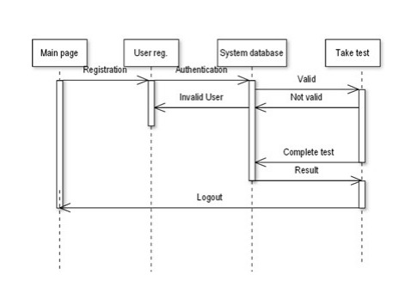

CHAPTER-4

IMPLEMENTATION

**4.IMPLEMENTATION**

**4.1 Sample code**

<!DOCTYPE html>

<html lang="en">

<head>

<meta charset="UTF-8">

<meta name="viewport" content="width=device-width, initial-scale=1.0">

<title>Student Login</title>

<style>

body {

font-family: Arial, sans-serif;

margin: 0;

padding: 0;

display: flex;

justify-content: center;

align-items: center;

height: 100vh;

background: linear-gradient(135deg, #ff9a9e, #fad0c4, #fad0c4, #ffdde1);

}

.container {

background-color: white;

padding: 30px;

border-radius: 10px;

box-shadow: 0 4px 6px rgba(0, 0, 0, 0.1);

width: 300px;

text-align: center;

}

h2 {

margin-bottom: 20px;

color: #333;

}

.form-group {

margin-bottom: 15px;

text-align: left;

}

label {

display: block;

font-weight: bold;

margin-bottom: 5px;

}

input {

width: 100%;

padding: 8px;

margin-top: 5px;

border: 1px solid #ccc;

border-radius: 5px;

}

button {

width: 100%;

padding: 10px;

background-color: #4CAF50;

color: white;

border: none;

border-radius: 5px;

cursor: pointer;

margin-top: 10px;

}

button:hover {

background-color: #45a049;

}

</style>

</head>

<body>

<div class="container" id="loginContainer">

<h2>Login</h2>

<form id="loginForm">

<div class="form-group">

<label for="loginEmail">Email:</label>

<input type="email" id="loginEmail" name="loginEmail" required>

</div>

<div class="form-group">

<label for="loginPassword">Password:</label>

<input type="password" id="loginPassword" name="loginPassword" required>

</div>

<button type="submit">Login</button>

</form>

</div>

<div class="container" id="registrationContainer" style="display: none;">

<h2>Student Registration</h2>

<form id="registrationForm">

<div class="form-group">

<label for="fullName">Full Name:</label>

<input type="text" id="fullName" name="fullName" required>

</div>

<div class="form-group">

<label for="email">Email:</label>

<input type="email" id="email" name="email" required>

</div>

<div class="form-group">

<label for="phone">Phone Number:</label>

<input type="text" id="phone" name="phone" required>

<button type="button" id="sendOtp">Send OTP</button>

</div>

<div class="form-group" id="otpField" style="display: none;">

<label for="otp">Enter OTP:</label>

<input type="text" id="otp" name="otp" required>

</div>

<div class="form-group">

<label for="password">Password:</label>

<input type="password" id="password" name="password" required>

</div>

<button type="submit">Register</button>

</form>

</div>

<script>

document.getElementById('loginForm').addEventListener('submit', function(event) {

event.preventDefault();

document.getElementById('loginContainer').style.display = 'none';

document.getElementById('registrationContainer').style.display = 'block';

});

document.getElementById('sendOtp').addEventListener('click', function() {

const phone = document.getElementById('phone').value;

if (phone) {

alert('OTP sent to ' + phone);

document.getElementById('otpField').style.display = 'block';

} else {

alert('Please enter a valid phone number.');

}

});

document.getElementById('registrationForm').addEventListener('submit', function(event) {

event.preventDefault();

const fullName = document.getElementById('fullName').value;

const email = document.getElementById('email').value;

const phone = document.getElementById('phone').value;

const otp = document.getElementById('otp').value;

const password = document.getElementById('password').value;

if (fullName && email && phone && otp && password) {

alert('Registration successful! Data saved successfully.');

} else {

alert('Please fill in all the fields.');

}

});

</script>

</body>

</html>

**4.2 Test Cases**

|  |  |  |  |  |  |  |  |  |  |  |  |  |  |  |  |  |  |  |  |  |  |  |  |  |
| --- | --- | --- | --- | --- | --- | --- | --- | --- | --- | --- | --- | --- | --- | --- | --- | --- | --- | --- | --- | --- | --- | --- | --- | --- |
| | **Test Case ID** | **Test Scenario** | **Test Steps** | **Expected Output** | **Actual Output** | **Status** | | --- | --- | --- | --- | --- | --- | | TC001 | Verify login with empty fields | Click the login button without entering email and password | Error message: "Please fill in all the fields." | As expected | Pass | | TC002 | Verify OTP functionality | Enter a valid phone number and click "Send OTP" | Alert: "OTP sent to [phone number]" | As expected | Pass | | TC003 | Verify registration with valid details | Fill all fields, enter OTP, and submit | Success message: "Registration successful!" | As expected | Pass | |

CHAPTER – 5

RESULTS

**5.RESULTS**

**5.1 Output Screens**

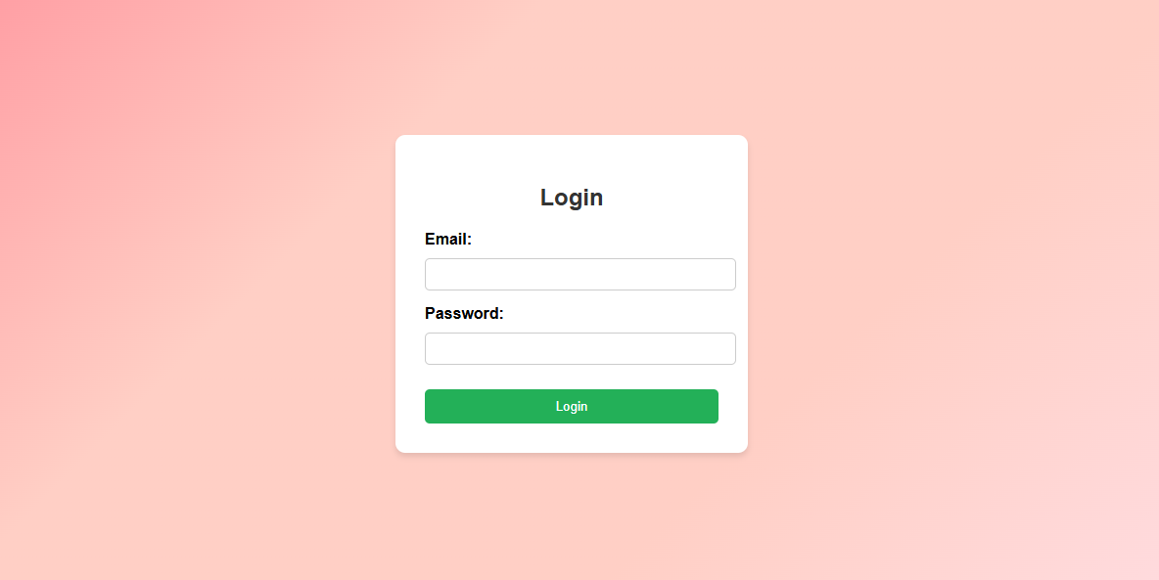

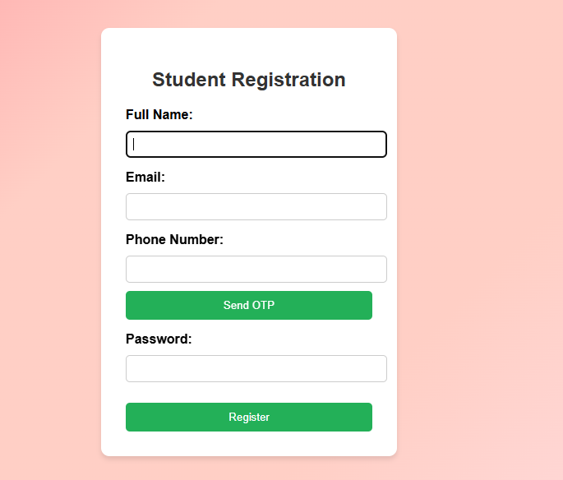

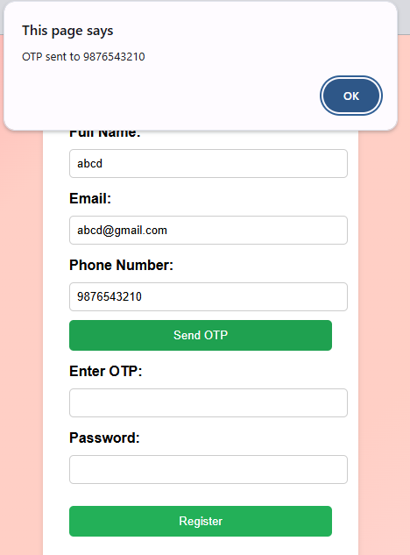

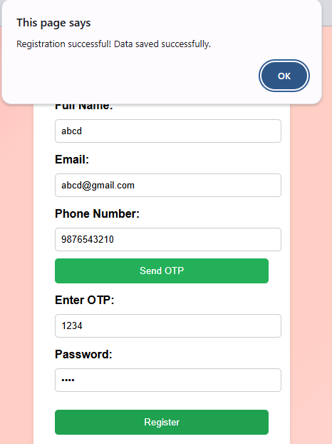

CHAPTER- 6

CONCLUSION

**6.CONCLUSION**

The student login and registration system was developed to streamline the process of user authentication and registration using a structured and user-friendly approach. The system successfully integrates login validation, OTP-based registration, client-side and server-side validation, and security measures to enhance user experience while ensuring data integrity.

The project effectively implements modern web development practices, incorporating responsive design, real-time validation, and error-handling mechanisms. The use of HTML, CSS, and JavaScript ensures a smooth and interactive user interface, while validation techniques help prevent incorrect data entry, reducing the risk of security breaches and user frustration.

One of the major advantages of this system is real-time OTP verification for phone numbers, which adds an additional layer of authentication, ensuring that only valid users can complete the registration process. This enhances the security of user accounts and minimizes fraudulent registrations. Furthermore, the system is designed to be mobile-friendly, allowing students to register or log in from various devices, including smartphones and tablets.

During the testing phase, multiple scenarios were evaluated, including valid and invalid logins, incorrect OTP entries, weak password detection, and form validation errors. These tests confirmed that the system provides clear feedback messages and prevents incorrect or incomplete submissions.

Future enhancements include integrating a backend database such as MySQL, Firebase, or MongoDB to securely store user credentials, implementing additional security features like two-factor authentication, CAPTCHA verification, and password encryption. Role-based access control can also be introduced to differentiate access levels for students, faculty, and administrators. Other possible improvements include email-based OTP verification, a password recovery mechanism, and integration with a student portal to provide access to academic information.

This project provides a foundation for a robust and secure student authentication system, ensuring ease of access while maintaining security. With further enhancements, it can evolve into a comprehensive student management system, providing greater functionality and efficiency in handling student records.

In conclusion, this project provides a **foundation for a robust and secure student authentication system**, ensuring ease of access while maintaining security. With further enhancements, it can evolve into a **comprehensive student management system**, providing greater functionality and efficiency in handling student records.

**REFERENCES**

**1.HTML & CSS Documentation – MDN Web Docs**

* Used for structuring and styling the student registration form.

<https://developer.mozilla.org/en-US/docs/Web>

**2.** **JavaScript Form Validation – W3Schools**

* Implemented client-side form validation for user input.

<https://www.w3schools.com/js/js_validation.asp>

**3.Bootstrap Forms – Bootstrap Documentation**

* Used Bootstrap framework for designing a responsive form layout.

<https://getbootstrap.com/docs/5.3/forms/overview/>

**4.Responsive Web Design – Google Developers**

* Ensured mobile-friendly design for the registration form.

<https://web.dev/responsive-web-design-basics/>

**5.Web Accessibility Guidelines (WCAG) – WebAIM**

* Followed accessibility guidelines for form usability.

<https://webaim.org/standards/wcag/>

**6.OTP Authentication System – Twilio API Documentation**

* Implemented phone number verification using OTP.

<https://www.twilio.com/docs/verify>

**7.Secure Login and Registration – OWASP Authentication Cheat Sheet**

* Followed security best practices for handling user credentials.

<https://cheatsheetseries.owasp.org/cheatsheets/Authentication_Cheat_Sheet.html>

**GITHUB LINK:** <https://github.com/likhitha48/fp.git>

**OUTPUT LINK:** <https://lucifer-the-end.github.io/field-project.b-11/MAIN_PAGE>